### **1.2 Interactive Ruby (IRB)**

**Theory:**

* IRB stands for Interactive Ruby Shell.
* It allows you to execute Ruby code in real-time, making it useful for testing snippets of code, debugging, and exploring the language.

**Using IRB:**

1. Open the terminal.
2. Type irb and press Enter.
3. You can now type Ruby commands and see the results immediately.

**Example:**

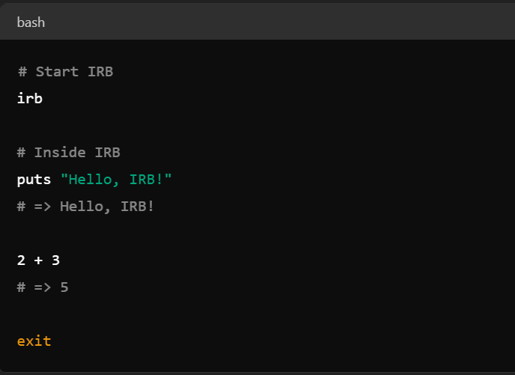

**Explanation of Example:**

* puts "Hello, IRB!" prints the string to the console.
* 2 + 3 performs an arithmetic operation and returns the result.
* exit exits the IRB session.